**AIM:** To create a Remote app.

**PROCEDURE:**

1. Define Purpose & Features:

Clearly outline the app's main function (e.g., controlling devices, monitoring systems, etc.). Identify core features like remote access, notifications, and device control.

2. User Interface Design:

Design a simple, intuitive UI with clear buttons and controls. Make navigation seamless, ensuring the user can easily access and manage remote functionalities.

3. Establish Secure Connections:

Implement secure authentication (e.g., two-factor authentication) and encryption protocols to ensure the remote app’s communications are safe.

4. Integrate with Devices:

Develop APIs or protocols (like Wi-Fi, Bluetooth, or IoT) to connect the app with the devices you want to control remotely.

5. Test & Optimize:

Conduct thorough testing for usability, performance, and security. Optimize for speed and reduce latency in remote actions.

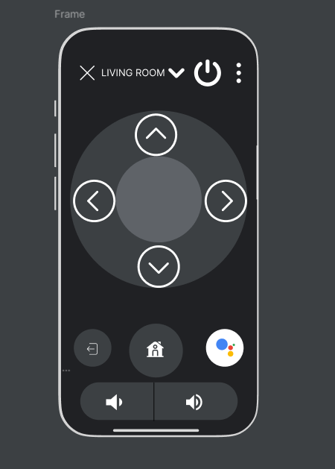

**RESULT:** Hence the design is completed and output is verified.